**Programming Fundamental LAB**

# **Assignment**

Question 1

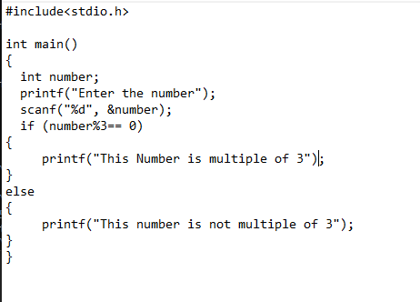

**OUTPUT**

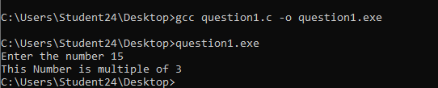

# **QUESTION 2**

**OUTPUT**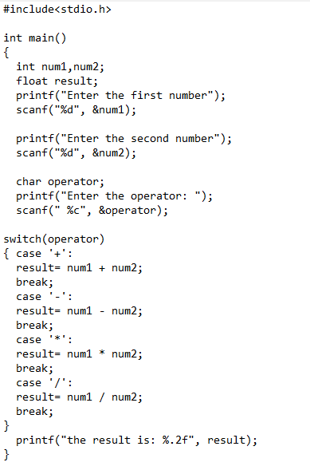

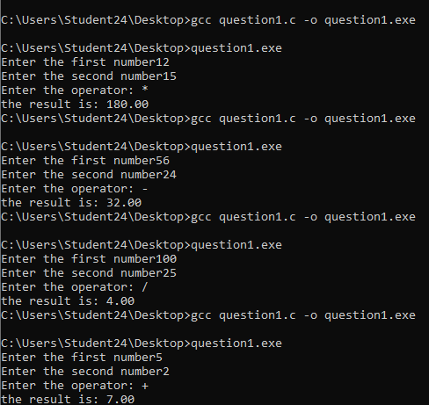

**Question 3:**

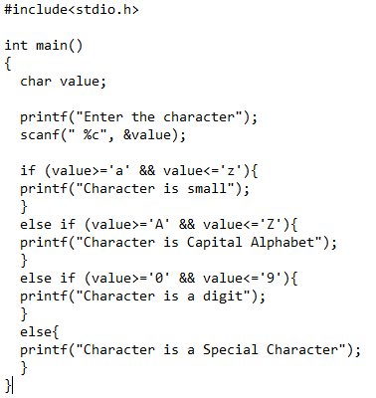

**OUTPUT**

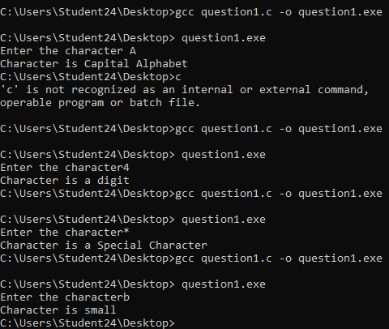

## **Question 4:**

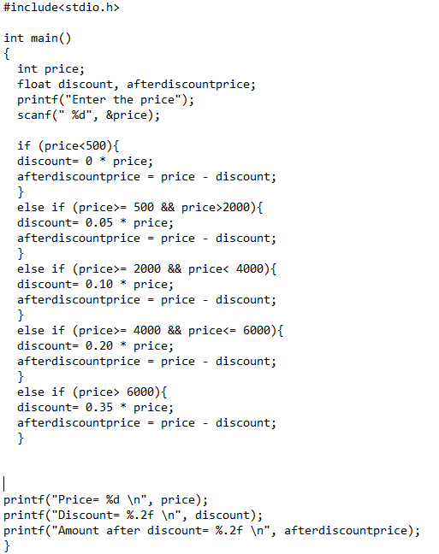

**OUTPUT**

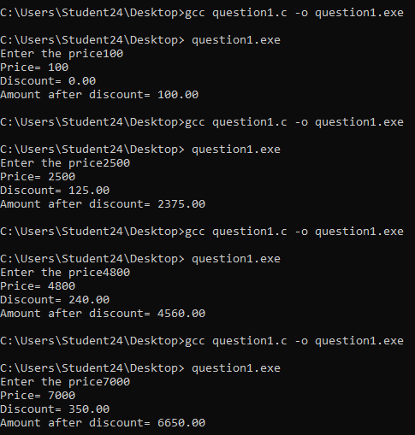

**Question 5**

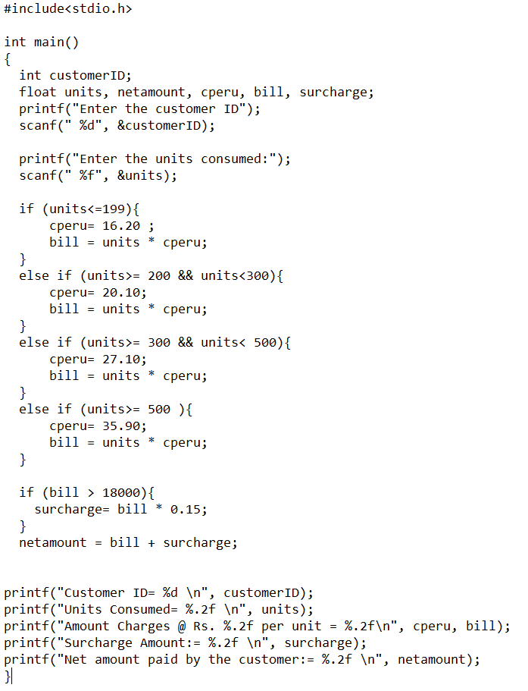

**OUTPUT**

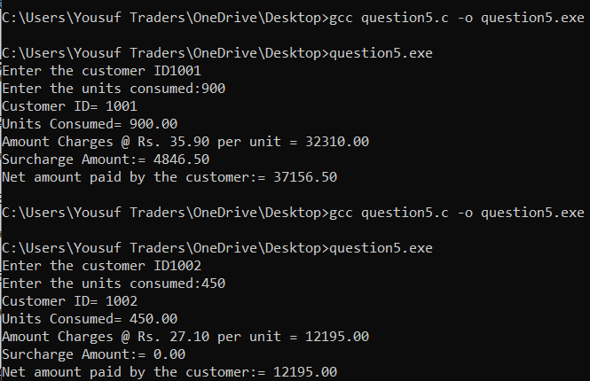

**QUESTION 6:**

**OUTPUT:**

